🔹 1. Basic Aggregation Formulas
- Total Sales
Total Sales = SUM(Sales[Amount])
- Average Sales
Average Sales = AVERAGE(Sales[Amount])
- Count of Orders
Order Count = COUNT(Sales[OrderID])

🔹 2. Conditional Calculations
- Sales Greater than 100
High Sales = CALCULATE(SUM(Sales[Amount]), Sales[Amount] > 100)
- Filter by Category
Electronics Sales = CALCULATE(SUM(Sales[Amount]), Sales[Category] = "Electronics")

🔹 3. Calculated Columns
- Profit Column
Profit = Sales[Revenue] - Sales[Cost]
- Profit Margin %
Profit Margin = DIVIDE(Sales[Profit], Sales[Revenue], 0)

🔹 4. Time Intelligence (very important 📊)
- Year-to-Date Sales
YTD Sales = TOTALYTD(SUM(Sales[Amount]), Sales[Date])
- Previous Year Sales
Previous Year Sales = CALCULATE(SUM(Sales[Amount]), SAMEPERIODLASTYEAR(Sales[Date]))

🔹 5. Ranking & Top Values
- Rank Products by Sales
Product Rank = RANKX(ALL(Sales[Product]), SUM(Sales[Amount]), , DESC)

🔹 6. Logical Functions
- IF Condition
Sales Category = IF(Sales[Amount] > 500, "High", "Low")

🔹 7. Distinct Count
Unique Customers = DISTINCTCOUNT(Sales[CustomerID])

🔹 8. RELATED Function (for relationships)
Customer Name = RELATED(Customers[Name])

🔹 9. ALL Function (remove filters)
Total Sales All = CALCULATE(SUM(Sales[Amount]), ALL(Sales))

🔹 10. Percentage of Total
% of Total Sales = DIVIDE(SUM(Sales[Amount]), CALCULATE(SUM(Sales[Amount]), ALL(Sales)))

Data Modeling:

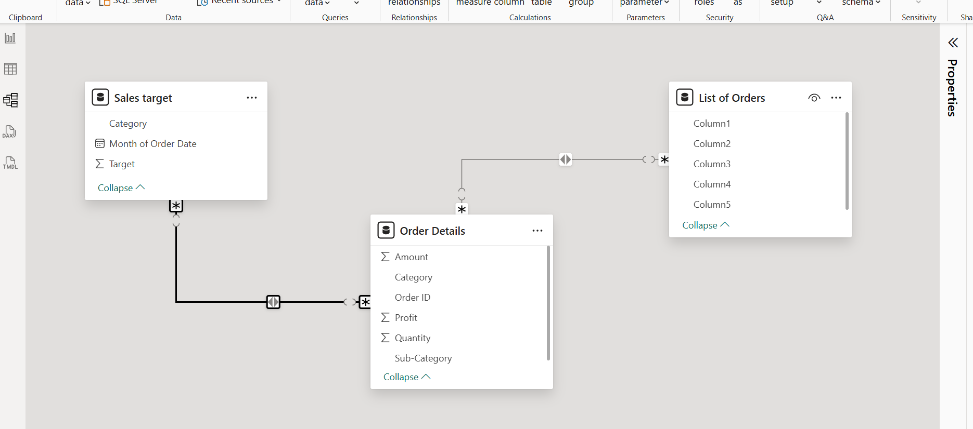

Category Type:

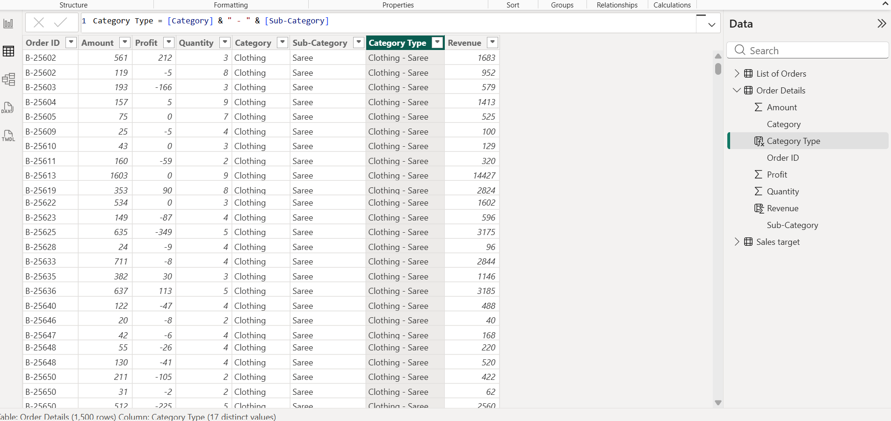

Revenue per Order:

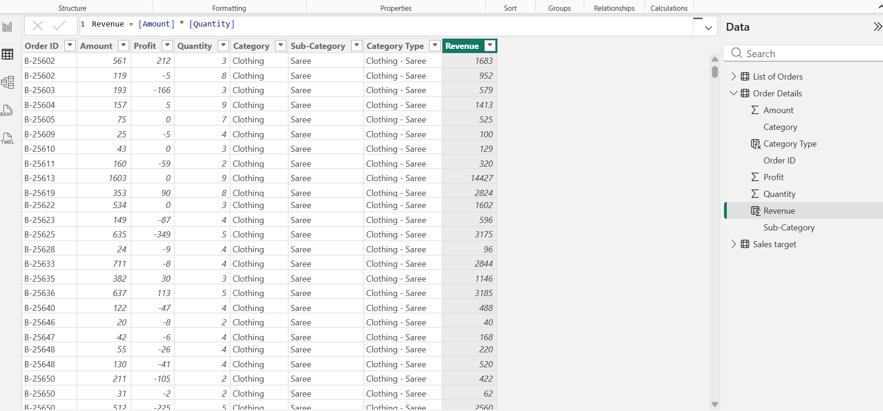

Sales Category:

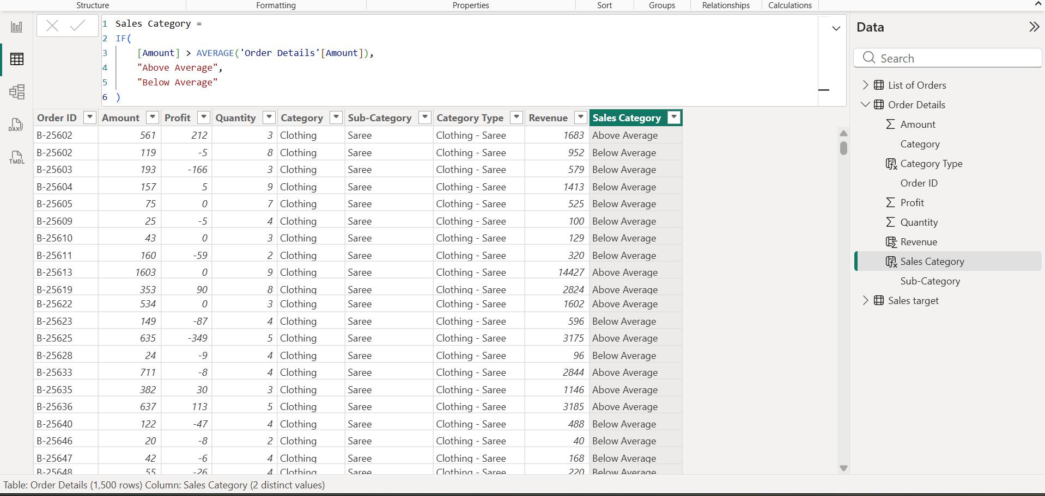

Sales Target vs Actual (Clustered Column Chart):

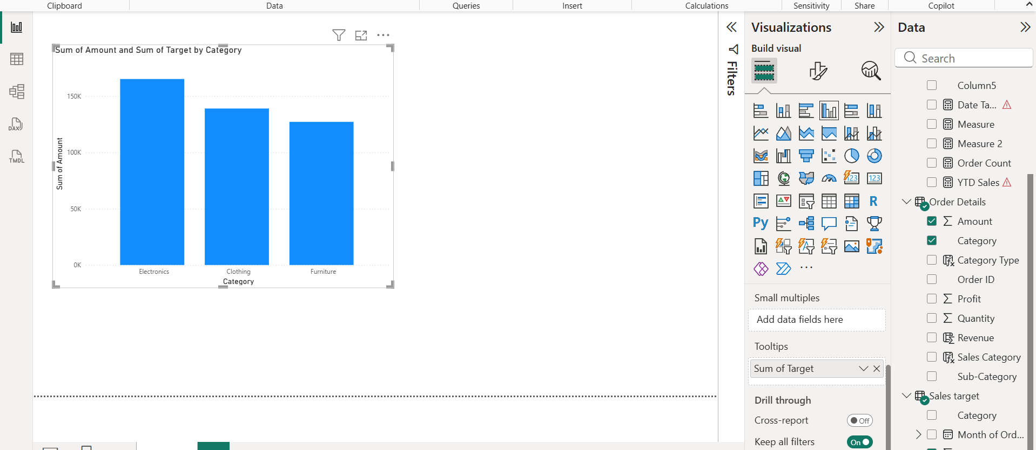

Max Profit Margin (Donut Chart):

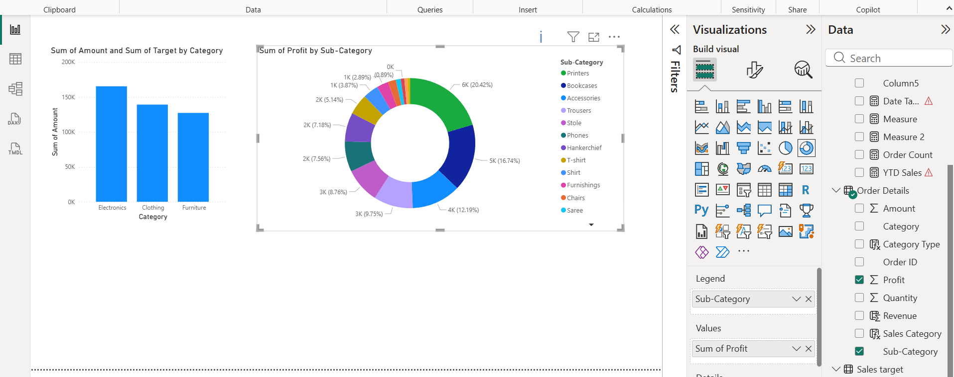

Monthly Sales Trend (Line Chart):

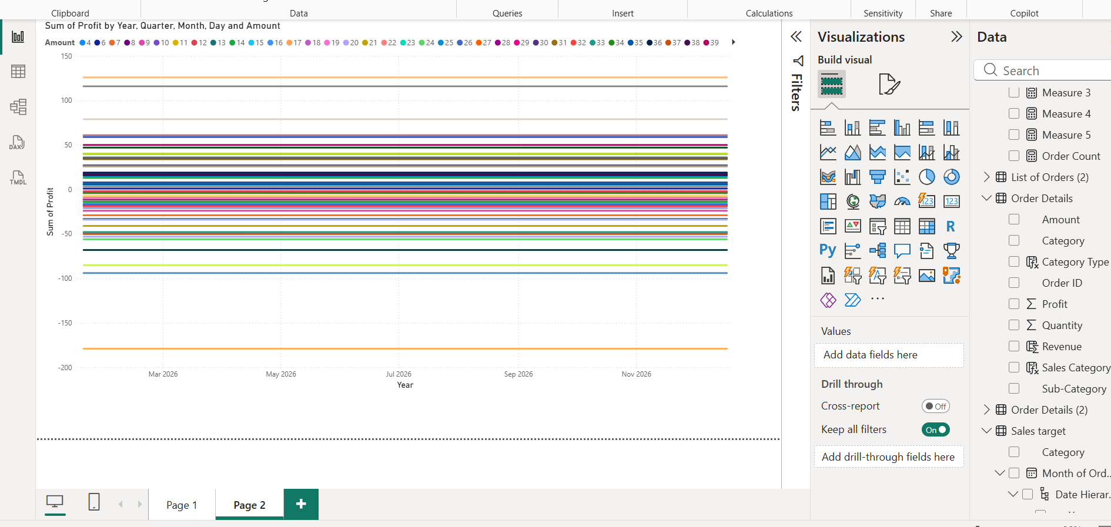

Scatter Chart:

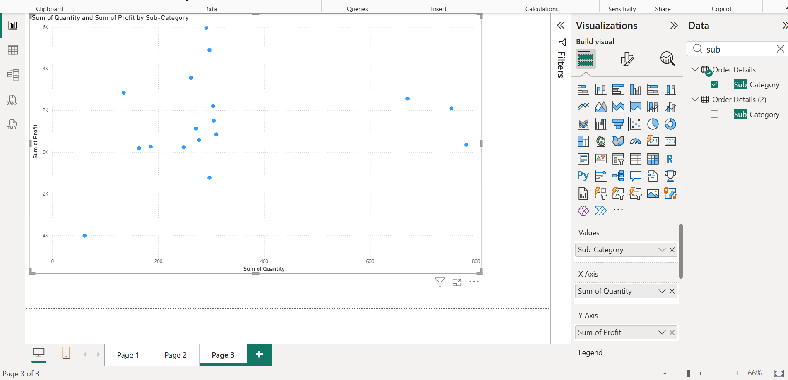

Cards:

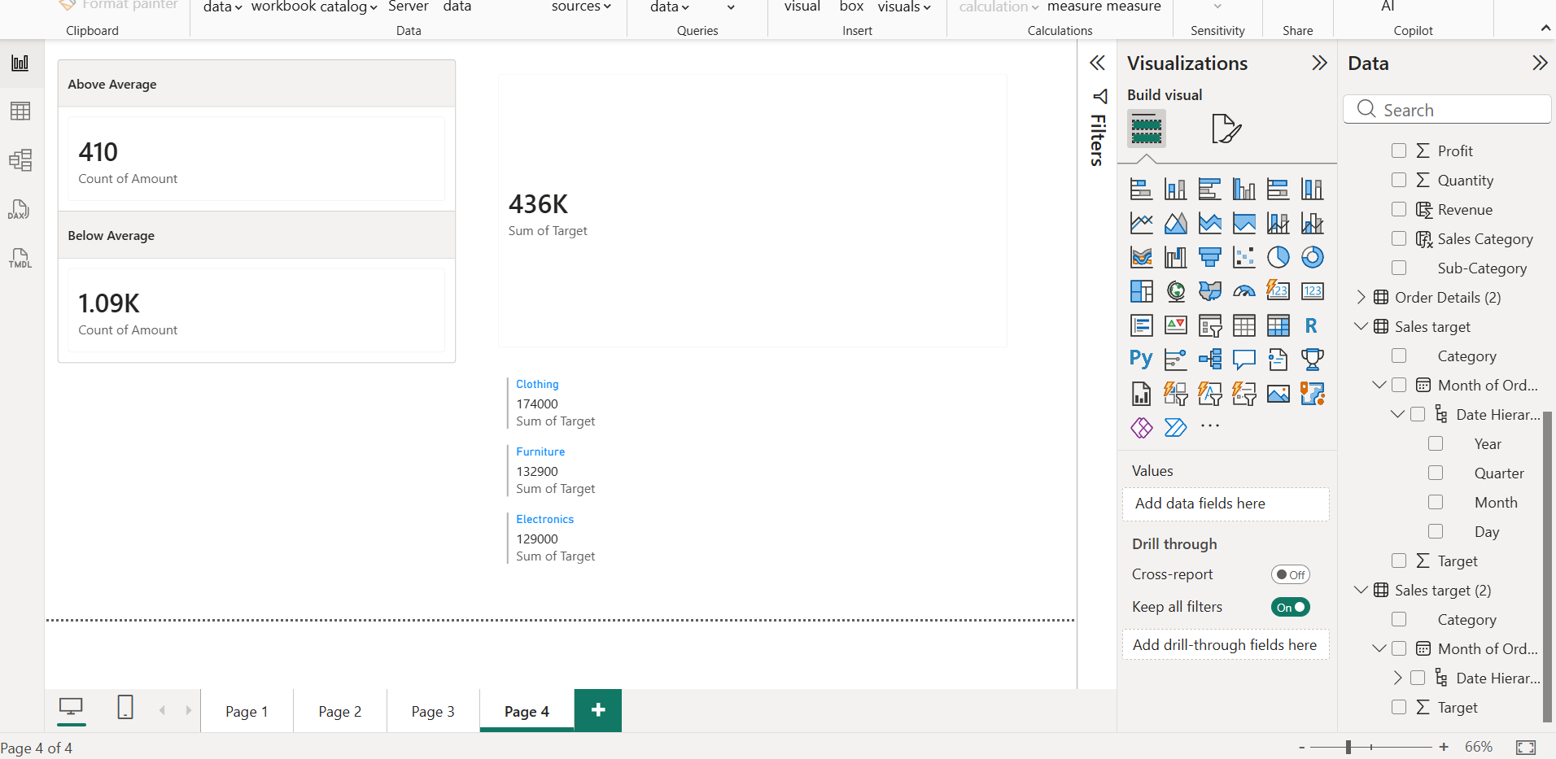

Matrix:

